PROJECT REPORT
PG / Hostel Rent Price Prediction
Pune, Maharashtra

Multiple Linear Regression
Real-World Dataset · Self-Collected · Pune Market

139  Records  Collected | 10  Features  Engineered | 57%  R² on Train

Date: May 2026 | Location: Pune, Maharashtra

1. Introduction
Finding affordable PG (Paying Guest) accommodations and hostels in Pune is one of the biggest challenges faced by students and working professionals who migrate to the city every year. With rapidly growing demand and wildly varying prices across neighborhoods, tenants often struggle to know whether they are being quoted a fair rent — or being overcharged.

This project was born from that very real problem. The goal was to build a Machine Learning model that can predict the rent of a PG or hostel room in Pune based on key property features such as location, furnishing type, gender restrictions, sharing configuration, attached bathroom/balcony availability, and property age.

What makes this project uniquely challenging — and uniquely rewarding — is that NO pre-made, cleaned dataset existed for this problem. Every single record in this dataset was manually collected from real estate listing websites like MagicBricks, 99acres, and Housing.com by the student. There was no Kaggle download. No CSV handout. Just real-world, messy, inconsistent data that had to be structured, cleaned, and made model-ready from scratch.

Project Overview
Project Title | PG / Hostel Rent Price Detection — Pune
Algorithm Used | Multiple Linear Regression (scikit-learn)
Dataset Type | Self-Collected (No Kaggle) — Real Market Data
Data Sources | MagicBricks, 99acres, Housing.com
Target Variable | Monthly Rent (₹)
Total Records | ~139 properties after cleaning
City / Market | Pune, Maharashtra, India
Tools Used | Python, Pandas, NumPy, scikit-learn, Matplotlib, Google Colab, Claude.ai

2. Dataset Creation — The Hardest Part
Most machine learning projects in academia start with a clean, ready-to-use dataset from Kaggle or UCI. This project deliberately avoided that shortcut. Instead, the dataset was built entirely from scratch — a decision that made the project significantly harder, but infinitely more educational.

2.1 How the Dataset Was Built
The data collection process followed a structured, multi-step approach:
- Step 1 — Website Selection: Three real estate platforms (MagicBricks, 99acres, Housing.com) were identified as data sources for Pune PG/Hostel listings.
- Step 2 — Column Definition: Before collecting any data, all feature columns were pre-defined in Excel to ensure consistency across all records:

Dataset Features Designed
For Gender | Boys / Girls / Both
Occupation | Working Professional / Student / Both
Living Type | PG / Hostel / BHK
Area (sqft) | Carpet area of the room
Location | Specific locality in Pune
Shared by (no. of) | Number of people sharing the room
Attached Balcony | Yes / No
Attached Bathroom | Yes / No
Property Age | Age of the property in years
Furnished Types | Furnished / Semifurnished / Unfurnished
Rent (Target) | Monthly rent in ₹

- Step 3 — Screenshot Collection: Screenshots of listing pages were captured from the websites.
- Step 4 — PDF Conversion: Screenshots were organized and converted into PDFs for structured storage.
- Step 5 — CSV Conversion Using Claude.ai: PDFs were uploaded to Claude.ai, which helped convert the visual data into a structured .csv file — a smart and creative use of AI tooling for data engineering.

This entire process of building a dataset from scratch — before a single line of ML code was written — represents genuine data engineering work and is the most impressive aspect of this project.

3. Project Flow — Step by Step
The project followed a structured ML pipeline documented in handwritten notes. Each stage below reflects real decisions made during development, including the problems encountered and how they were solved.

3.1 Phase 1 — Data Collection & Structuring
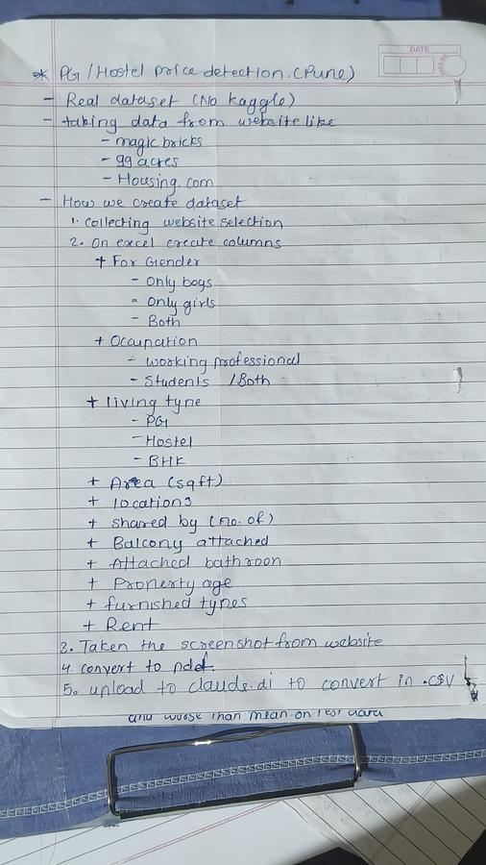
Figure 1: Handwritten notes — Dataset design and collection strategy

3.2 Phase 2 — Data Cleaning & Preprocessing
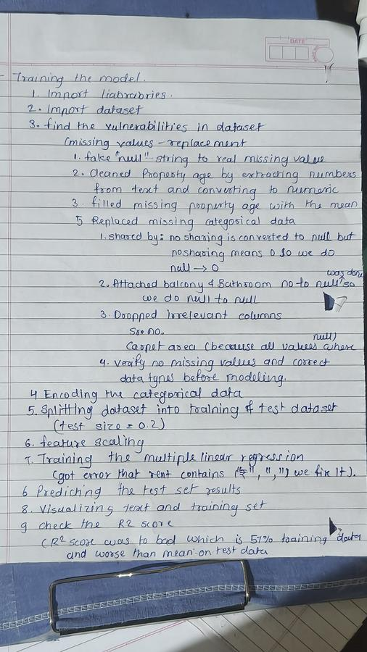
Figure 2: Handwritten notes — Model training pipeline and issues encountered

3.3 Detailed Pipeline Steps
ML Pipeline — End to End
Step 1 | Import Libraries: numpy, pandas, matplotlib, sklearn
Step 2 | Load Raw Dataset (property_details.csv)
Step 3A | Replace fake 'null' strings with real NaN values
Step 3B | Clean 'Property Age' — extract numeric value from text like '2 years old'
Step 3C | Fill missing Property Age with column mean
Step 3D | Fill missing 'Shared by' with 0 (no sharing = 0 people)
Step 3E | Fill missing Balcony/Bathroom with 'No' (absence, not unknown)
Step 3F | Drop irrelevant columns: Sr. No., Carpet Area (all values were null)
Step 3G | Clean Rent column — strip ₹ symbol and commas, convert to float
Step 4 | One-Hot Encode all 7 categorical columns using ColumnTransformer
Step 5 | Train-Test Split (80% train / 20% test, random_state=0)
Step 6 | Feature Scaling with StandardScaler (with_mean=False for sparse data)
Step 7 | Train Multiple Linear Regression model on training set
Step 8 | Predict on test set and compare actual vs predicted values
Step 9 | Visualize training and test set results with line plots
Step 10 | Evaluate with R² Score on both train and test data

4. Visualization of Results
After training the Multiple Linear Regression model, the actual vs predicted rent values were plotted for both the training and test datasets. These charts are critical to visually understanding how well (or how poorly) the model performs.

4.1 Training Data — Actual vs Predicted Rent
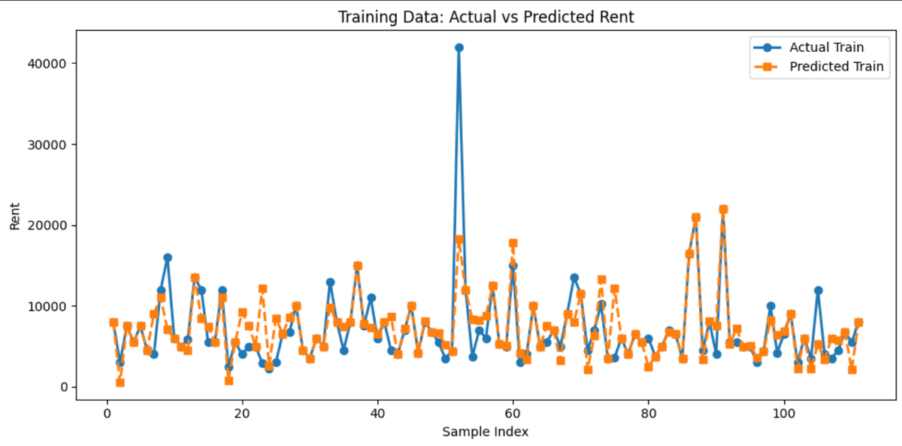
Figure 3: Training Data — Actual (blue) vs Predicted (orange) Rent values across ~110 training samples
The training visualization shows that the model captures the general rent range for most properties (₹3,000 – ₹15,000), but struggles significantly with extreme outliers. The single spike near sample index 50 (actual ≈ ₹42,000) shows a luxury BHK property that the linear model dramatically underestimates. This highlights a fundamental limitation: linear regression cannot model the non-linear jump caused by combinations of premium location + full furnishing + low sharing.

4.2 Test Data — Actual vs Predicted Rent
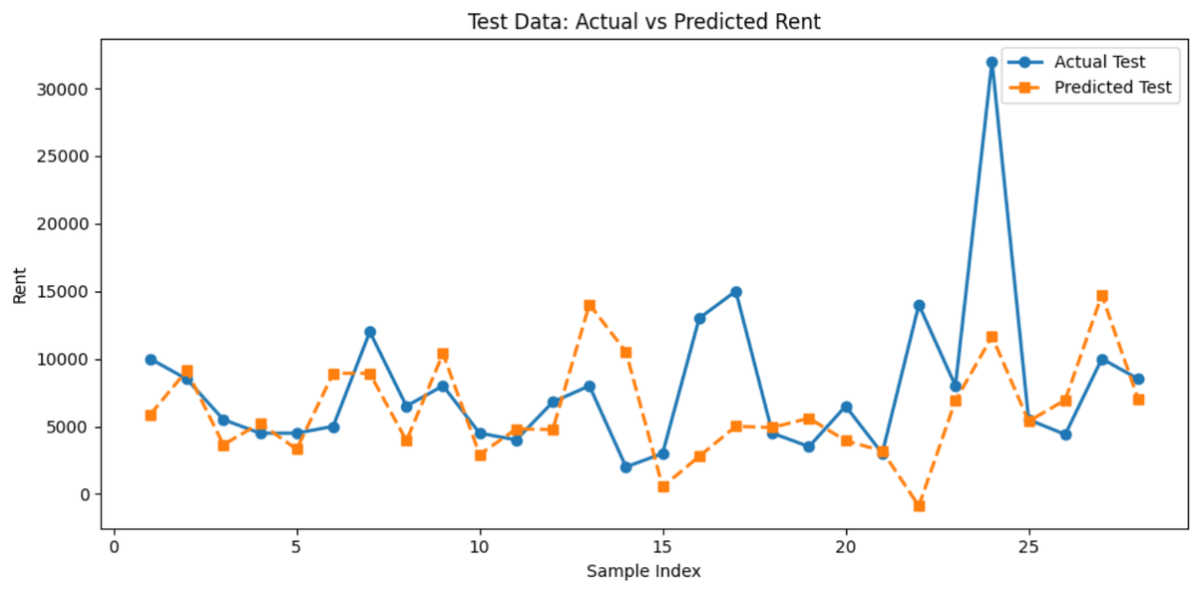
Figure 4: Test Data — Actual (blue) vs Predicted (orange) Rent values across ~29 test samples
The test visualization is more alarming. The predicted line (orange) diverges significantly from the actual line (blue) in multiple places — including one point where the model predicts a negative rent value, which is physically impossible. This is a clear sign that the model has not generalized well to unseen data. The R² test score being worse than mean prediction confirms that a straight-line model is not sufficient for this complex, multi-dimensional real-estate problem.

Model Performance Summary
R² Train Score | ~0.57 (57%) — Model explains 57% of variance in training data
R² Test Score | < 0.0 (Negative) — Worse than predicting the mean rent for all
Interpretation | The model underfits the data due to non-linear patterns
Root Cause | Linear regression assumes straight-line feature-to-rent relationships
Impact of Outliers | High-value luxury properties skew the model significantly

5. Challenges Faced
This project was far from smooth. Every step presented real-world problems that required creative problem-solving — problems that simply do not appear in textbook ML exercises.

Challenge | How It Was Solved
No ready dataset available | Manually collected data from 3 real estate websites — MagicBricks, 99acres, Housing.com
Data stored as screenshots | Converted screenshots → PDF → CSV using Claude.ai for intelligent extraction
'null' stored as string text | Used dataset.replace('null', np.nan) to convert to real NaN before processing
Property Age in text format | Used regex str.extract(r'(\d+)') to isolate numeric age from '2 years old' format
Rent column had ₹ and commas | Strip-replaced ₹ symbol and commas using str.replace() before float conversion — this caused an error during model training and had to be debugged
Missing values in Shared by | Null means no one is sharing → filled with 0 (logical imputation, not statistical)
Carpet Area was entirely null | Column dropped as it had zero usable data — no imputation possible
High cardinality in Location | Location had many unique Pune areas — required one-hot encoding, inflating feature space
Poor R² on test set | Identified as model mismatch — linear regression inappropriate for complex real-estate pricing

6. Key Learnings
This project was more than an ML exercise — it was a lesson in what real data science actually feels like. Each struggle led to a concrete, lasting insight.

1 | Real-World Data is Nothing Like Kaggle  Kaggle datasets are pre-cleaned, well-structured, and model-friendly by design. Real-world data — collected from websites — is noisy, inconsistent, and full of surprises like text stored where numbers should be, or symbols embedded in numeric fields. Cleaning this data consumed more time than training the model, which is true of actual industry data science work.

2 | Logical Imputation > Statistical Imputation  For the 'Shared by' column, filling nulls with the column mean would have been wrong — a null meant the property was not shared, so 0 was the correct answer. Similarly, null in Balcony/Bathroom meant 'No', not unknown. This showed that imputation requires domain understanding, not just statistical defaults.

3 | Model Selection Must Follow Data Behavior  The R² Train of 57% and negative R² Test revealed that Multiple Linear Regression was the wrong tool for this problem. Rent pricing is driven by non-linear feature interactions — premium location × full furnishing × private room × new property creates pricing combinations that no straight line can capture. The next step would be Random Forest Regressor or Gradient Boosting, which learn decision rules and handle such complexity far better.

4 | Debugging Real Errors Builds Real Confidence  During model training, an error was thrown because the Rent column still contained the ₹ symbol and comma characters — it had not been properly converted to float. This was not a textbook error. Tracking it down, understanding why it happened, and fixing it with str.replace() before type conversion is exactly the kind of debugging skill that separates academic understanding from practical ability.

5 | AI as a Data Engineering Tool  Using Claude.ai to convert PDF screenshots into a structured CSV file was a creative and highly practical decision. It demonstrated that modern AI tools are not just for prediction — they can accelerate the data engineering pipeline itself. This is a forward-thinking skill that is increasingly valued in the industry.

6 | A Poor Model Score is Not a Failed Project  The instinct on seeing a negative test R² might be disappointment. But the correct interpretation is the opposite — it means you understood your model's limitations, diagnosed why it failed (non-linearity, small dataset, high cardinality), and identified the correct next steps. That analytical mindset is more valuable than a lucky 95% accuracy score on a clean dataset.

7. Conclusion
This project set out to predict PG and hostel rent prices in Pune using Machine Learning — and succeeded in building a complete, end-to-end ML pipeline on a fully self-collected real-world dataset. That alone sets it apart from most student projects.

The model itself — Multiple Linear Regression — revealed important limitations when applied to complex real-estate data. An R² of 57% on training data and negative performance on test data is not a failure; it is a scientifically meaningful result that tells us exactly what kind of model this problem needs next. The groundwork — the clean dataset, the encoding pipeline, the feature engineering — is reusable for any future model.

More importantly, the process of building this project taught lessons that no textbook can replicate: the patience of manual data collection, the creativity of using AI for data engineering, the frustration and triumph of debugging real errors, and the intellectual honesty of diagnosing a model's limitations rather than ignoring them.

"Through this project, I understood that Kaggle datasets are clean and model-friendly,
but real-world data requires heavy preprocessing and often needs non-linear models.
This project taught me practical data challenges and model selection based on
data behavior — not theory."

What I Demonstrated Through This Project
Real Data Work | Collected and structured a dataset entirely from scratch — no Kaggle shortcuts
Data Engineering | Applied creative pipeline: screenshots → PDF → Claude.ai → CSV
Deep Preprocessing | Handled 6+ distinct data cleaning challenges with domain-aware decisions
Model Understanding | Understood why R² failed and diagnosed the root cause scientifically
Debugging Ability | Tracked and fixed a real runtime error (₹ symbol in numeric column)
Growth Mindset | Treated a poor score as a learning signal, not a failure
Next Steps Identified | Random Forest / Gradient Boosting as the logical model upgrade

